*Naïve Bayes*

It is specifically use for classification problem & it performs really well with textual data.

& It performs really well with Textual Data

Koibhi Text Based Problem hum krrhe hai, so Usme yeah use hota hai

Ish tarike ke applications keliye Naïve Bayes acts like a baseline model.

Naïve Bayes Performs really well with textual data.

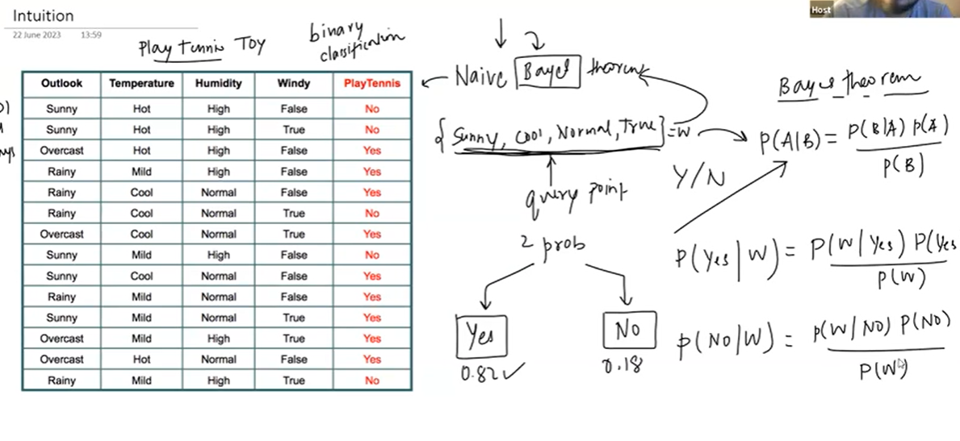

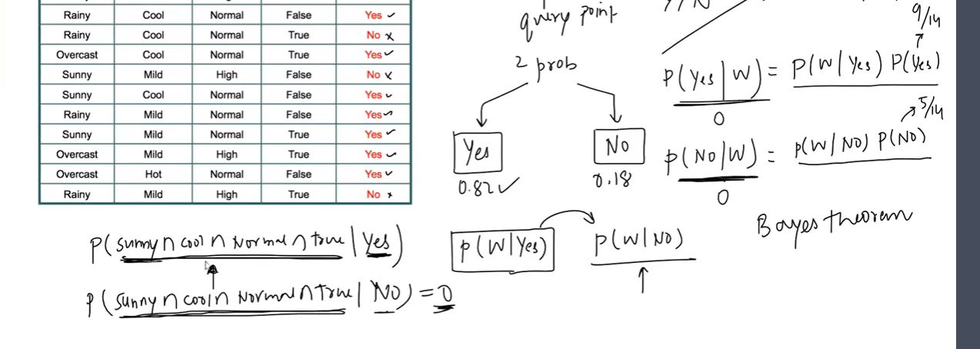

This is the Problem of Bayes Theorem,

Jbh Bhaut saare Input columns hote hai so unsbhka Combinations mille yeah zarruri nahi hai.

So isliye Naïve Bayes humara Naïve Assumption leta hai

🡪

Vo kya krta hai ki Probability ko Breakdown krdeta hai

**E.g:**

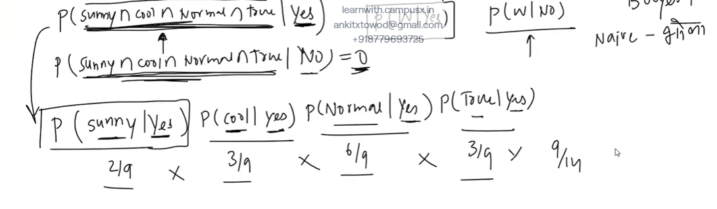

Naïve Bayes mai Naïve word yeahi se aaya jo yeah Breakdown krrha hai

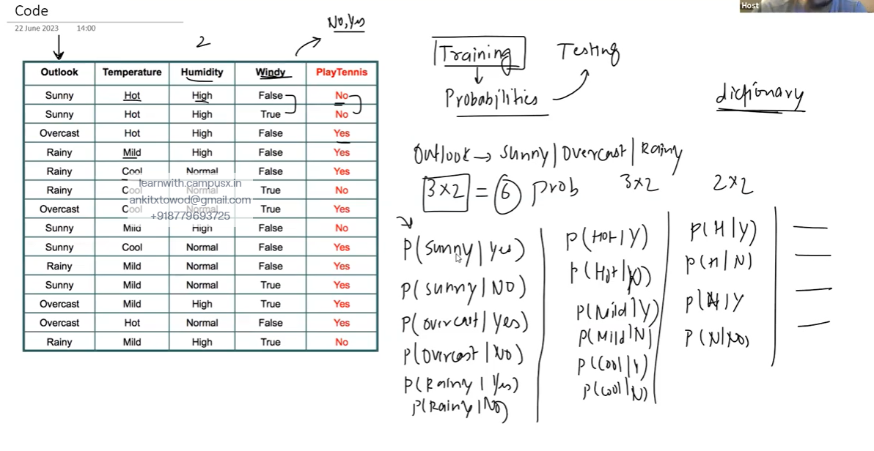

*How Naïve Bayes Handles Numerical Data*

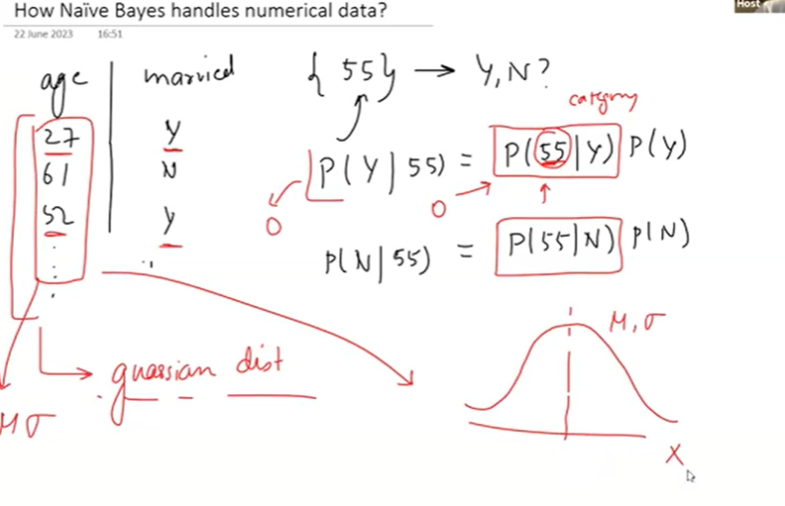

Yeah basically jo 1 column hai foe e.g Age usko Gaussian Distribution hum assume krte hai

